2.64: Taking the start of the race as the origin, runner A's speed at the end of 30 m can be found from:

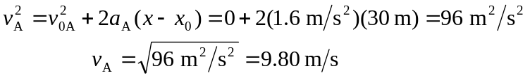

A’s time to cover the first 30 m is thus:

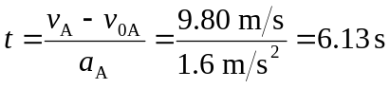
and A’s total time for the race is:
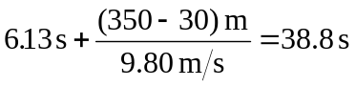
B’s speed at the end of 30 m is found from:

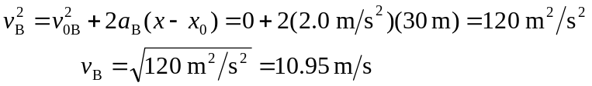
B’s time for the first 30 m is thus
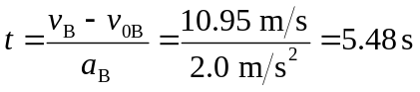
and B's total time for the race is:
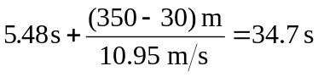

B can thus nap for 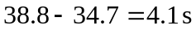and still finish at the same time as A.

